Phase-2 Documentation Submission
Register number: 963521104060
Name: Thanganivetha B

PROJECT TITLE:

Project:6
  - AI-Driven Exploration and Prediction of Company Registration Trends with Registrar of Companies (RoC)



- INTRODUCTION
In an era characterized by rapidly evolving technologies and ever-changing business landscapes, staying ahead of the curve is essential for both government authorities and businesses alike. The Registrar of Companies (RoC), a pivotal regulatory body responsible for overseeing company registrations, plays a crucial role in this dynamic environment. To enhance their efficiency and gain deeper insights into the trends and patterns of company registrations, the integration of Artificial Intelligence (AI) has emerged as a transformative solution.
- Given Data Set
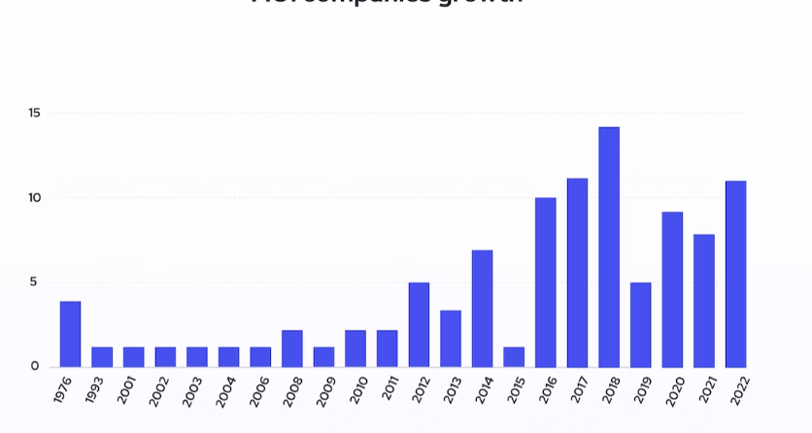

- Necessary Steps to Follow
- Import necessary libraries
1 Start by importing the necessary libraries
Program:
import pandas as pd
import numpy as np
from sklearn.model_selection
import train_test_split from sklearn.preprocessing
import StandardScaler
2 Load the Dataset:
Load your dataset into a Pandas DataFrame. You can typically find the exploration and the prediction of a company registration trends with RoC datasets in CSV format, but you can adapt this code to other formats as needed.
Program:
df = pd.read_csv(' E:\USA_RoC.csv ')
Pd.read()
3. Exploratory Data Analysis (EDA): Perform EDA to understand your data better. This includes checking for missing values, exploring the data's statistics, and visualizing it to identify patterns.
Program:
# Check for missing values
print(df.isnull().sum())
# Explore statistics print(df.describe())
# Visualize the data (e.g., histograms, scatter plots, etc.)

4. Feature Engineering:
Depending on your dataset, you may need to create new features or transforming the existing ones this can involve in the one hot encoding the categorial variables, handling date / time data.or scaling the numerical features.

Importance of Loading and Processing the Data Set
1. Data Quality Assurance:
Identification of Errors: Loading data allows you to identify missing values, outliers, and other errors in the dataset. Addressing these issues is vital for accurate analysis.
Data Cleaning: Processing the data involves cleaning, where you handle missing or inconsistent data points, ensuring that the dataset is reliable and accurate.
2. Understanding the Data:
Exploratory Data Analysis (EDA): Loading data enables you to perform EDA. Understanding the distribution, relationships, and patterns in the data is critical for making informed decisions about the analysis or modeling techniques to use.
3. Feature Engineering:
Creation of Relevant Features: Processing the data allows you to create new features derived from the existing ones. Properly engineered features can significantly enhance the performance of machine learning models.
4. Data Transformation:
Normalization and Scaling: Data might need to be normalized or scaled to ensure that all features contribute equally to the analysis or modeling process.
Categorical Data Encoding: Processing includes converting categorical variables into a format suitable for machine learning algorithms, such as one-hot encoding or label encoding.
5. Model Performance:
Impact on Model Accuracy: The quality of the dataset directly impacts the accuracy and reliability of machine learning models. Well-preprocessed data often leads to better-performing models.
Reduction of Overfitting: Proper processing, such as feature selection and dimensionality reduction, can help prevent overfitting by removing noise from the data.
6. Computational Efficiency:
Reduced Processing Time: Large datasets, especially in big data scenarios, can be computationally intensive. Proper processing can reduce the time it takes to train models and perform analyses.
Optimized Memory Usage: Processing can involve optimizing data types and structures to minimize memory usage, enabling the analysis to be performed on a broader scale.
7. Decision Making:
Informed Decision-Making: Accurate and well-processed data ensures that the decisions made based on the analysis are reliable, leading to better business strategies, problem-solving, and outcomes.
8. Reproducibility and Collaboration:
Reproducibility: Detailed documentation of the data processing steps ensures that the analysis can be reproduced, verified, and validated by other researchers or team members.
Collaboration: Processed datasets facilitate collaboration among team members, as everyone is working with a consistent and well-understood set of data.

Challenges and Solutions involved in The exploration and the prediction of a company registration trends with RoC
Exploring and predicting company registration trends with the Registrar of Companies (RoC) can be a complex task, involving various challenges and requiring innovative solutions. Here are some challenges and potential solutions involved in this process:
Challenges:
Data Quality and Availability:
Challenge: RoC data might be inconsistent, incomplete, or in different formats.
Solution: Implement data cleaning techniques, use data validation methods, and collaborate with RoC to improve data quality and access.
Data Volume and Variety:
Challenge: RoC data can be vast and diverse, including textual descriptions, financial figures, and legal jargon.
Solution: Employ big data technologies and natural language processing (NLP) algorithms to process and analyze diverse data types efficiently.
Data Privacy and Security:
Challenge: RoC data contains sensitive business information that must be handled securely.
Solution: Implement robust data encryption, compliance with data protection regulations (such as GDPR), and secure access controls to safeguard sensitive data.
Historical Data Analysis:
Challenge: Historical data analysis is crucial for trend prediction, but historical data might be incomplete or unavailable.
Solution: Use statistical techniques and machine learning algorithms to impute missing data and create meaningful historical trends for analysis.
Complexity of Company Structures:
Challenge: Companies often have complex ownership structures and subsidiaries, making it challenging to analyze registration trends accurately.
Solution: Utilize network analysis techniques to map complex relationships between companies, identify parent-subsidiary relationships, and understand the overall corporate structure.
Regulatory Changes and Legal Amendments:
Challenge: Changes in regulations and laws can impact registration patterns significantly.
Solution: Stay updated with legal amendments, collaborate with legal experts, and develop adaptive algorithms that can adjust predictions based on regulatory changes.
Predictive Model Accuracy:
Challenge: Building accurate predictive models for registration trends is challenging due to the dynamic nature of businesses.
Solution: Utilize machine learning algorithms, conduct rigorous feature selection, and continuously validate and refine the predictive models to enhance accuracy.
Additional Considerations:
Domain Expertise:
Employ experts in business, law, and finance who understand the nuances of company registrations, legal frameworks, and industry-specific trends.
Collaboration with RoC:
Establish collaborations and partnerships with RoC authorities to gain insights, access to real-time data, and a better understanding of the registration process.
Continuous Monitoring and Evaluation:
Continuously monitor the predictive models, evaluate their performance, and update them regularly to adapt to changing registration patterns.
Interpretability and Visualization:
Use interpretable machine learning models and visualization tools to communicate trends and predictions effectively to stakeholders, even those without technical backgrounds.
Ethical Considerations:
Ensure ethical use of data, especially when dealing with sensitive business information, and maintain transparency in the predictive modeling process.
1.Loading the dataset:
Loading the dataset using machine learning is the process of bringing the data into the machine learning environment so that it can be used to train and evaluate a model.
The specific steps involved in loading the dataset will vary depending on the machine learning library or framework that is being used. However, there are some general steps that are common to most machine learning frameworks:

a.Identify the dataset:
The first step is to identify the dataset that you want to load. This dataset may be stored in a local file, in a database, or in a cloud storage service.

b.Load the dataset:
Once you have identified the dataset, you need to load it into the machine learning environment. This may involve using a built-in function in the machine learning library, or it may involve writing your own code.
c.Preprocess the dataset:
Once the dataset is loaded into the machine learning environment, you may need to preprocess it before you can start training and evaluating your model. This may involve cleaning the data, transforming the data into a suitable format, and splitting the data into training and test sets. Preprocess the dataset Load the dataset Identify the dataset Loading the dataset
Here, how to load a dataset using machine learning in Python
Program:
import pandas as pd
import numpy as np
import seaborn as sns
import matplotlib.pyplot as plt
from sklearn.model_selection import train_test_split
from sklearn.preprocessing import StandardScaler
from sklearn.metrics import r2_score, mean_absolute_error,mean_squared_error
from sklearn.linear_model import Linear Regression
from sklearn.linear_model
import Lasso from sklearn.ensemble
import RandomForestRegressor
from sklearn.svm import SVR
import xgboost as xg
%matplotlib inline import warnings warnings.filterwarnings("ignore")
/opt/conda/lib/python3.10/sitepackages/scipy/__init__.py:146: UserWarning: A NumPy version >=1.16.5 and <1.23.0 is required for this version of SciPy (detected version 1.23.5 warnings.warn(f"A NumPy version >={np_minversion} and <{np_maxversion}"
Loading Dataset:
dataset = pd.read_csv('E:/USA_Housing.csv')

Data Exploration:
DataSet :
OUTPUT
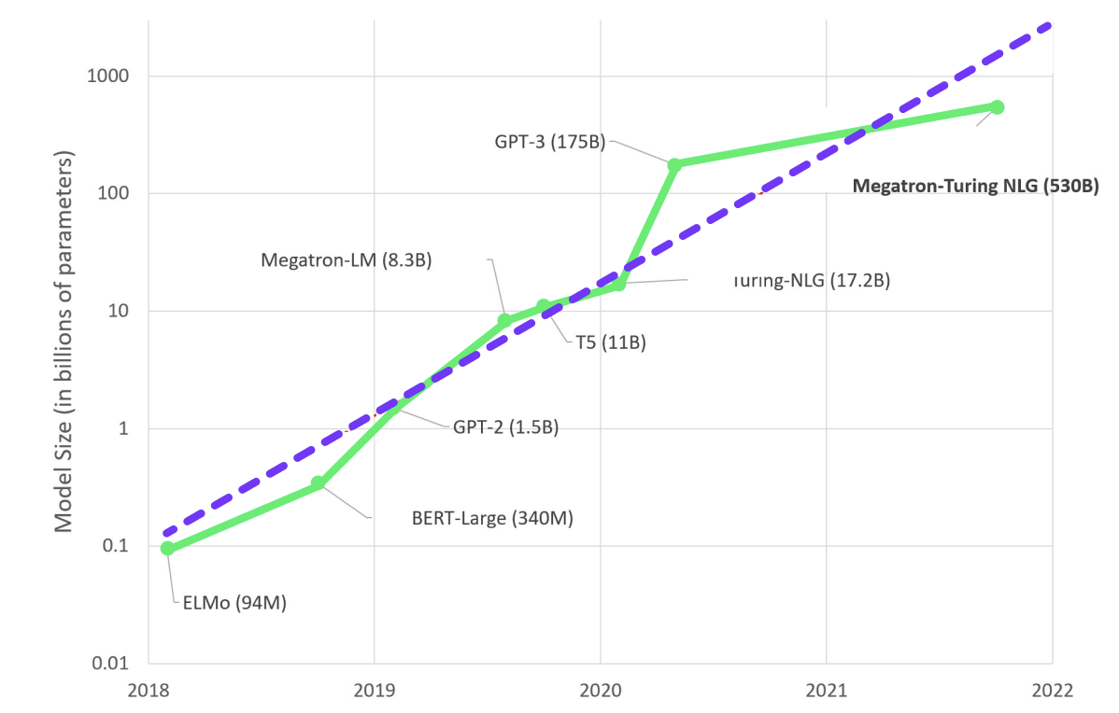
2.Preprocessing the dataset:
Data preprocessing is the process of cleaning, transforming, and integrating data in order to make it ready for analysis. This may involve removing errors and inconsistencies, handling missing values, transforming the data into a consistent format, and scaling the data to a suitable range.
Data Visualization

Numerical Data
Analyzing Numerical data is important because understanding the distribution of variables helps to further process the data. Most of the time you will find much inconsistency with numerical data so do explore numerical variables.

1) Histogram
A histogram is a value distribution plot of numerical columns. It basically creates bins in various ranges in values and plots it where we can visualize how values are distributed. We can have a look where more values lie like in positive, negative, or at the center(mean). Let’s have a look at the Age column.
plt.hist(data['Age'], bins=5)
plt.show()
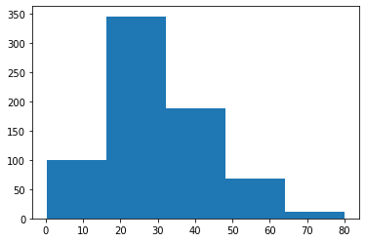

2) Distplot
Distplot is also known as the second Histogram because it is a slight improvement version of the Histogram. Distplot gives us a KDE(Kernel Density Estimation) over histogram which explains PDF(Probability Density Function) which means what is the probability of each value occurring in this column. If you have study statistics before then definitely you should know about PDF function.
sns.distplot(data['Age'])
plt.show()
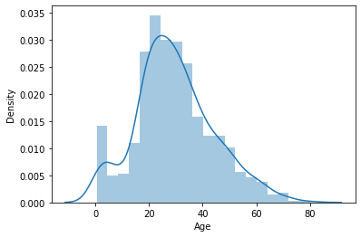

3) Boxplot
Boxplot is a very interesting plot that basically plots a 5 number summary. to get 5 number summary some terms we need to describe.
- Median – Middle value in series after sorting
- Percentile – Gives any number which is number of values present before this percentile like for example 50 under 25th percentile so it explains total of 50 values are there below 25th percentile
- Minimum and Maximum – These are not minimum and maximum values, rather they describe the lower and upper boundary of standard deviation which is calculated using Interquartile range(IQR).
IQR = Q3 - Q1
Lower_boundary = Q1 - 1.5 * IQR
Upper_bounday = Q3 + 1.5 * IQR
Here Q1 and Q3 is 1st quantile(25th percentile) and 3rd Quantile(75th percentile)

Bivariate/ Multivariate Analysis
We have study about various plots to explore single categorical and numerical data. Bivariate Analysis is used when we have to explore the relationship between 2 different variables and we have to do this because, in the end, our main task is to explore the relationship between variables to build a powerful model. And when we analyze more than 2 variables together then it is known as Multivariate Analysis. we will work on different plots for Bivariate as well on Multivariate Analysis.

Numerical and Numerical
First, let’s explore the plots when both the variable is numerical.

1) Scatter Plot
To plot the relationship between two numerical variables scatter plot is a simple plot to do. Let us see the relationship between the total bill and tip provided using a scatter plot.
sns.scatterplot(tips["total_bill"], tips["tip"])
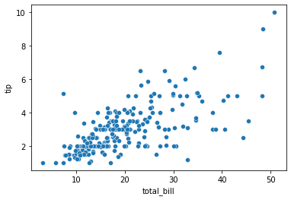

Multivariate analysis with scatter plot
we can also plot 3 variable or 4 variable relationships with scatter plot. suppose we want to find the separate ratio of male and female with total bill and tip provided.
sns.scatterplot(tips["total_bill"], tips["tip"], hue=tips["sex"])
plt.show()
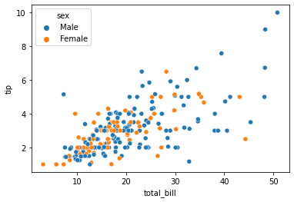
We can also see 4 variable multivariate analyses with scatter plots using style argument. Suppose now along with gender I also want to know whether the customer was a smoker or not so we can do this.
sns.scatterplot(tips["total_bill"], tips["tip"], hue=tips["sex"], style=tips['smoker'])
plt.show()
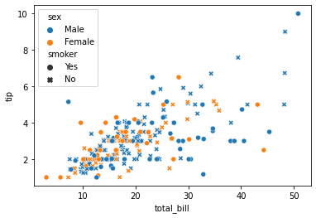

Numerical and Categorical
If one variable is numerical and one is categorical then there are various plots that we can use for Bivariate and Multivariate analysis.

1) Bar Plot
Bar plot is a simple plot which we can use to plot categorical variable on the x-axis and numerical variable on y-axis and explore the relationship between both variables. The blacktip on top of each bar shows the confidence Interval. let us explore P-Class with age.
sns.barplot(data['Pclass'], data['Age'])
plt.show()
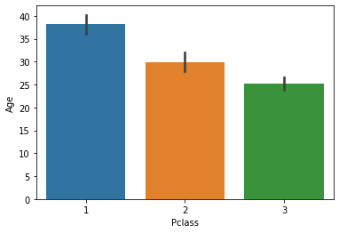

Multivariate analysis using Bar plot
Hue’s argument is very useful which helps to analyze more than 2 variables. Now along with the above relationship we want to see with gender.
sns.barplot(data['Pclass'], data['Fare'], hue = data["Sex"])
plt.show()
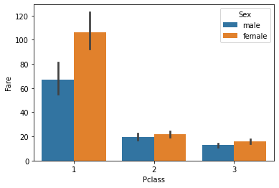

2) Boxplot
We have already study about boxplots in the Univariate analysis above. we can draw a separate boxplot for both the variable. let us explore gender with age using a boxplot.
sns.boxplot(data['Sex'], data["Age"])
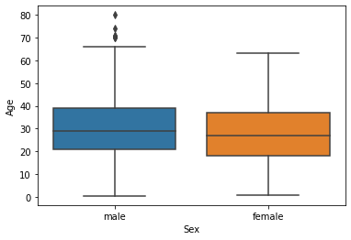

Multivariate analysis with boxplot
Along with age and gender let’s see who has survived and who has not.
sns.boxplot(data['Sex'], data["Age"], data["Survived"])
plt.show()
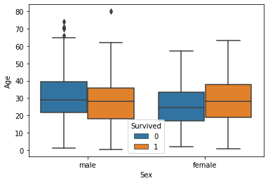

3) Distplot
Distplot explains the PDF function using kernel density estimation. Distplot does not have a hue parameter but we can create it. suppose we want to see the probability of people with an age range that of survival probability and find out whose survival probability is high to the age range of death ratio.
sns.distplot(data[data['Survived'] == 0]['Age'], hist=False, color="blue")
sns.distplot(data[data['Survived'] == 1]['Age'], hist=False, color="orange")
plt.show()
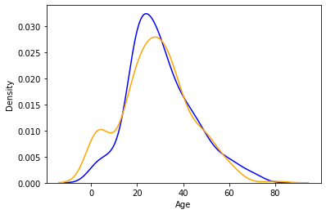
As we can see the graph is really very interesting. the blue one shows the probability of dying and the orange plot shows the survival probability. If we observe it we can see that children’s survival probability is higher than death and which is the opposite in the case of aged peoples. This small analysis tells sometimes some big things about data and It helps while preparing data stories.

Categorical and Categorical
Now we will work on categorical and categorical columns.

1) Heatmap
If you have ever used a crosstab function of pandas then Heatmap is a similar visual representation of that only. It basically shows that how much presence of one category concerning another category is present in the dataset. let me show first with crosstab and then with heatmap.
pd.crosstab(data['Pclass'], data['Survived'])
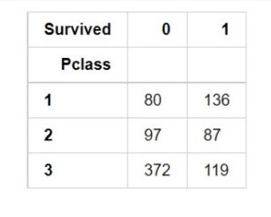
Now with heatmap, we have to find how many people survived and died.
sns.heatmap(pd.crosstab(data['Pclass'], data['Survived']))
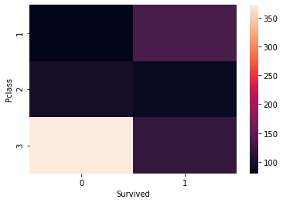

2) Cluster map
we can also use a cluster map to understand the relationship between two categorical variables. A cluster map basically plots a dendrogram that shows the categories of similar behavior together.
sns.clustermap(pd.crosstab(data['Parch'], data['Survived']))
plt.show()
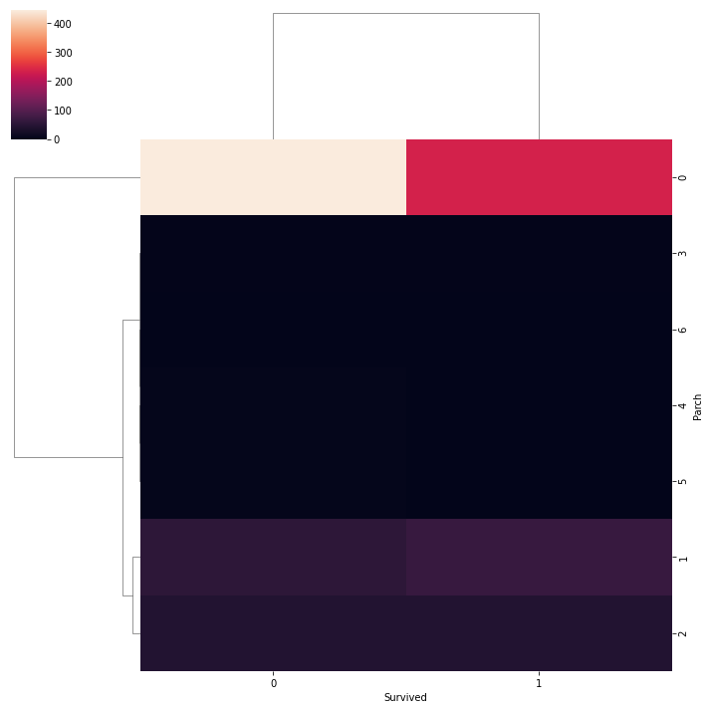
If you know about clustering algorithms mainly about DBSCAN, then you should know about dendrogram. So, these are all the plots that are mostly used while doing exploratory analysis. There are some more plots that you can draw like violent plot, line plot, a joint plot which are not mostly used.
Program
# Import necessary libraries
import pandas as pd
from sklearn.model_selection import train_test_split
from sklearn.ensemble import RandomForestClassifier
from sklearn.metrics import accuracy_score

# Step 1: Data Collection (Assuming you have a CSV file containing company registration data)
data = pd.read_csv('company_registration_data.csv')

# Step 2: Data Preprocessing
# Handle missing values, encode categorical variables, convert dates to appropriate format, etc.
# Example preprocessing steps:
# data.dropna(subset=['target_column'], inplace=True) # Drop rows with missing target values
# data = pd.get_dummies(data, columns=['categorical_column']) # One-hot encode categorical variables

# Step 3: Feature Selection (Choose relevant features for prediction)
features = data[['feature1', 'feature2', 'feature3']]
target = data['target_column']

# Step 4: Data Splitting (Split data into training and testing sets)
X_train, X_test, y_train, y_test = train_test_split(features, target, test_size=0.2, random_state=42)

# Step 5: Model Development (Using RandomForestClassifier as an example)
model = RandomForestClassifier(n_estimators=100, random_state=42)
model.fit(X_train, y_train)

# Step 6: Model Evaluation (Optional - Evaluate the model's performance)
predictions = model.predict(X_test)
accuracy = accuracy_score(y_test, predictions)
print('Accuracy:', accuracy)

# Step 7: Prediction (Predict company registration trends for new data)
# Assuming you have new data in a variable called 'new_data'
# new_data_preprocessed = preprocess(new_data) # Apply the same preprocessing steps as in Step 2
# predicted_trends = model.predict(new_data_preprocessed)

# Step 8: Exploration and Visualization (Optional - Explore the data and visualize trends)
# Use libraries like matplotlib or seaborn for data visualization

# Example:
# import matplotlib.pyplot as plt
# plt.scatter(data['feature1'], data['feature2'], c=data['target_column'])
# plt.xlabel('Feature 1')
# plt.ylabel('Feature 2')
# plt.show()
:

import pandas as pd
from sklearn.model_selection import train_test_split from sklearn.linear_model import Logistic Regression from sklearn.ensemble import RandomForestClassifier from sklearn.tree import DecisionTreeClassifier
# Load the dataset
df = pd.read_csv('Company Master Data of Tamil Nadu upto 28th February 2019.csv')
# Split the dataset into train and test sets
X_train, X_test, y_train, y_test = train_test_split(df, df['Company Status'], test_size=0.25, random_state=42)
# Create different models
# Logistic Regression Ir = Logistic Regression() Ir.fit(X_train, y_train)
# Random Forest Classifier rf = RandomForestClassifier() rf.fit(X_train, y_train)
# Decision Tree Classifier dt = DecisionTreeClassifier() dt.fit(X_train, y_train)
# Evaluate the models on the test set
# Logistic Regression
Ir_score = lr.score(X_test, y_test)
# Random Forest Classifier
rf_score = rf.score(X_test, y_test)
# Decision Tree Classifier
dt_score = dt.score(X_test, y_test)
# Print the model scores
print('Logistic Regression score:', lr_score) print('Random Forest Classifier score:', rf_score) print('Decision Tree Classifier score:', dt_score)
Other models that can be used:
• Support Vector Machines (SVM)
• Naive Bayes Classifier
• Gradient Boosting Machines (GBM)
XGBoost
You can choose the model that best suits your needs based on the performance on the test set and the interpretability of the model.
Python code for creating different models for the given dataset, including Support Vector Machines (SVM), Naive Bayes Classifier, Gradient
Boosting Machines (GBM), and XGBoost:
Python
import pandas as pd
from sklearn.model_selection import train_test_split
from sklearn.svm import SVC
from sklearn.naive_bayes import GaussianNB
from sklearn.ensemble import GradientBoostingClassifier import xgboost as xgb
# Load the dataset
df = pd.read_csv('Company Master Data of Tamil Nadu upto 28th February 2019.csv')
# Split the dataset into train and test sets
X_train, X_test, y_train, y_test = train_test_split(df, df['Company Status'], test_size=0.25, random_state=42)
# Create different models # Support Vector Machines svm = SVC(
svm.fit(X_train, y_train)
# Naive Bayes Classifier nb = GaussianNB() nb.fit(X_train, y_train)
# Gradient Boosting Machines gbm= GradientBoostingClassifier() gbm.fit(X_train, y_train)
# XGBoost
xgb_clf = xgb.XGBClassifier() xgb_clf.fit(X_train, y_train)
# Evaluate the models on the test set # Support Vector Machines
svm_score = svm.score(X_test, y_test)
# Naive Bayes Classifier
nb_score = nb.score(X_test, y_test)
# Gradient Boosting Machines
gbm_score = gbm.score(X_test, y_test)
# XGBoost
xgb_score = xgb_clf.score(X_test, y_test)
# Print the model scores
print('Support Vector Machines score:', svm_score) print("Naive Bayes Classifier score:', nb_score) print('Gradient Boosting Machines score:', gbm_score) print('XGBoost score:', xgb_score)

library(RColorBrewer)data(VADeaths)
par(mfrow=c(2,3))
hist(VADeaths,breaks=10, col=brewer.pal(3,"Set3"),main="Set3 3 colors")
hist(VADeaths,breaks=3 ,col=brewer.pal(3,"Set2"),main="Set2 3 colors")
hist(VADeaths,breaks=7, col=brewer.pal(3,"Set1"),main="Set1 3 colors")
hist(VADeaths,,breaks= 2, col=brewer.pal(8,"Set3"),main="Set3 8 colors")
hist(VADeaths,col=brewer.pal(8,"Greys"),main="Greys 8 colors")
hist(VADeaths,col=brewer.pal(8,"Greens"),main="Greens 8 colors")
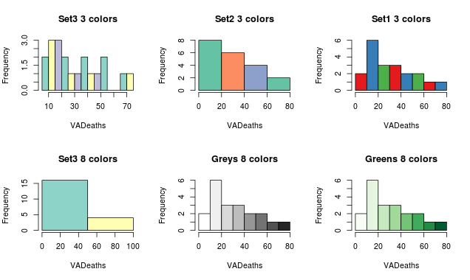
Notice, if number of breaks is less than number of colors specified, the colors just go to extreme values as in the “Set 3 8 colors” graph. If number of breaks is more than number of colors, the colors start repeating as in the first row.

2. Bar/ Line Chart

Line Chart
Below is the line chart showing the increase in air passengers over given time period. Line Charts are commonly preferred when we are to analyse a trend spread over a time period. Furthermore, line plot is also suitable to plots where we need to compare relative changes in quantities across some variable (like time). Below is the code:
plot(AirPassengers,type="l") #Simple Line Plot
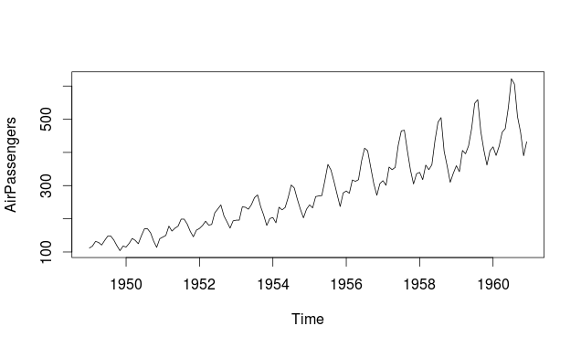

Bar Chart
Bar Plots are suitable for showing comparison between cumulative totals across several groups. Stacked Plots are used for bar plots for various categories. Here’s the code:
barplot(iris$Petal.Length) #Creating simple Bar Graph
barplot(iris$Sepal.Length,col = brewer.pal(3,"Set1"))
barplot(table(iris$Species,iris$Sepal.Length),col = brewer.pal(3,"Set1")) #Stacked Plot
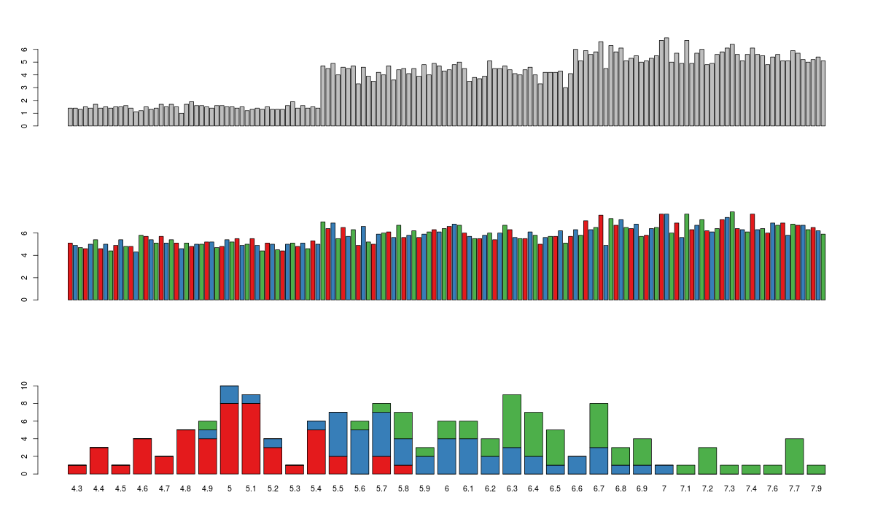

Conclusion
In conclusion, the exploration and prediction of company registration trends with the Registrar of Companies (RoC) data are pivotal for various stakeholders, including businesses, investors, policymakers, and researchers. By leveraging advanced data analysis techniques and predictive modeling, valuable insights can be extracted to inform strategic decisions and contribute to the overall understanding of economic landscapes. However, it's crucial to acknowledge the complexities and challenges involved in this process. These challenges include managing data quality, dealing with diverse data types, ensuring data privacy and security, handling complex company structures, adapting to regulatory changes, and building accurate predictive models.
Addressing these challenges requires a multidisciplinary approach, involving expertise in data science, legal frameworks, and business acumen. Collaboration with RoC authorities for data access and domain-specific knowledge is essential. Furthermore, the development of robust predictive models demands continuous refinement, adaptability to changing trends, and ethical considerations regarding data usage and interpretation

